The list of the Diagrams the we need to prepare before development that need to be done.

Back-End:

* Prototype I – Lynkd web application Entity Relationship Diagram – ER (we need to keep this updated)

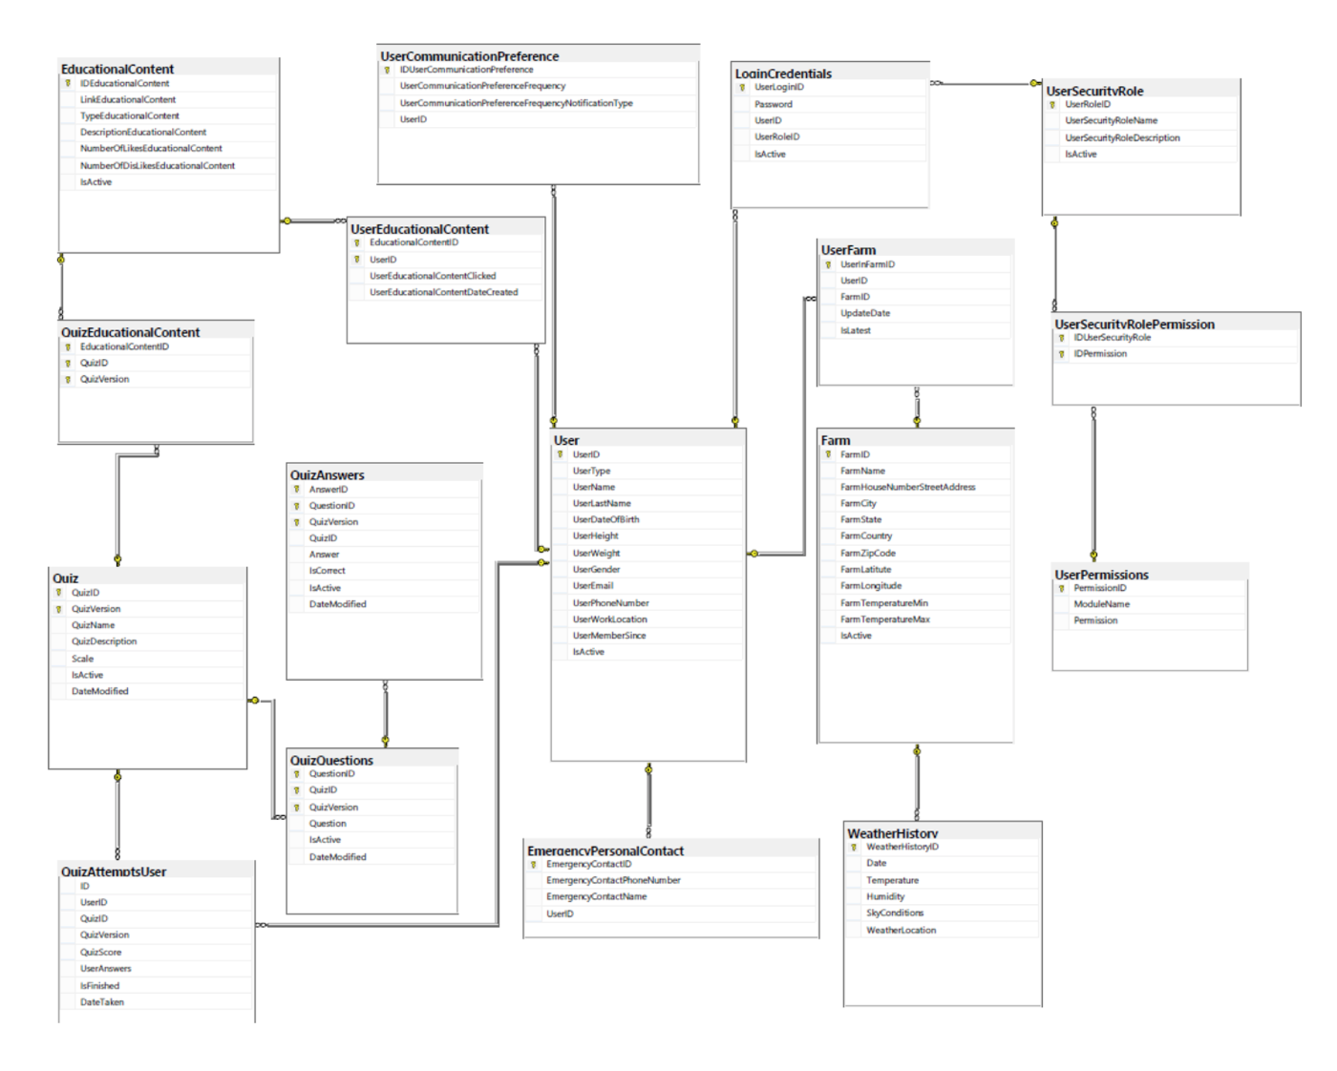

* Use Case Diagram

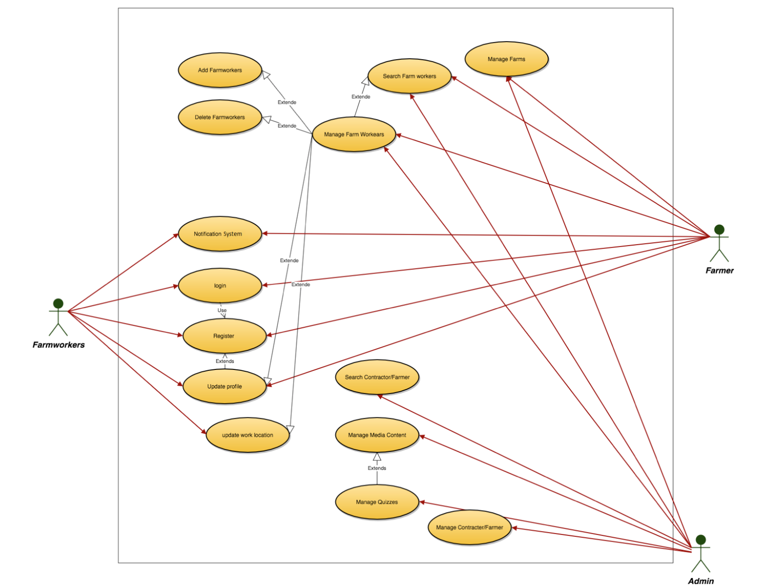

* Process Realization Diagram for suppliers and start ups

